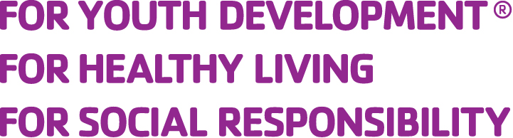
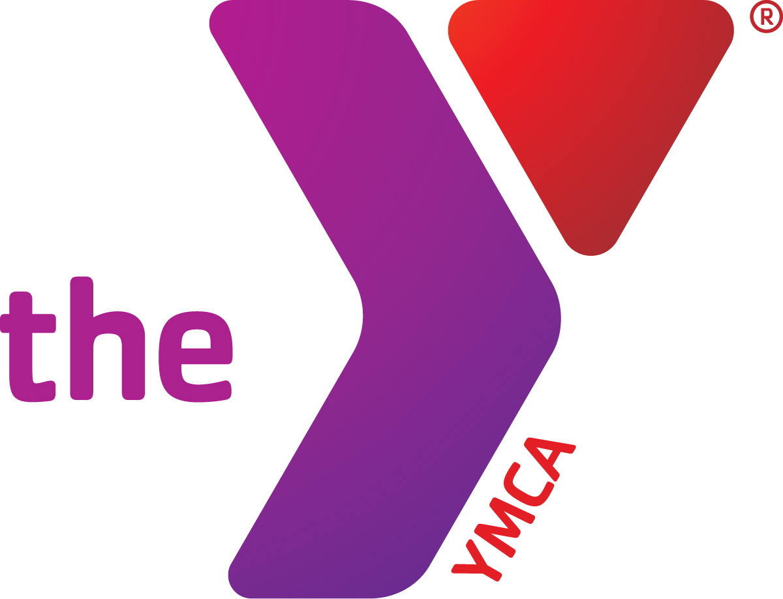

Direct Debit of
Checking or Savings Account

Tri-Town YMCA announces the Direct Debit Program
for our clients. This program utilizes electronic funds transfer to provide you with a timely, accurate and convenient way to pay for Tri-Town YMCA programs.
Tri-Town YMCA
1464 S. Main St.
Entrance #7
Lombard, IL 60148
P 630-629-9622
F 630-629-4636
info@tritownymca.org
 | Instructions: Please complete the form below. Attach an unsigned, voided check from this account and turn in to Tri-Town YMCA. The Y will process through its Bank.
I (we) authorize Tri-Town YMCA hereafter called "TTYMCA", to initiate debit entries to my (our) checking account indicated below and the Bank named below, hereinafter called "Bank", to debit the same such account.
I (we) further authorize “TTYMCA” to initiate credits to my (our) account to correct any errors, and "Bank" to initiate any such corrections to my (our) account. This authority is to remain in full force and effect until "TTYMCA" and "Bank" has received written notification from me (or either of us) of its termination in such time and in such manner as to afford "TTYMCA" and "Bank" a reasonable opportunity to act on it prior to depositing to the account.

Frequency (circle one): Weekly Monthly In the amount of $_____________ To begin ___/____/____
To end _________ or at program withdrawal which requires written confirmation sent to the Tri-Town YMCA office.
Today’s Date ___________/__________/___________ |  | Bank Name
Customer Signature |  | Bank Address
Customer Name |  | Bank Phone Number
Address |  | Bank Routing #
City, State, Zip |  | Bank Account Number
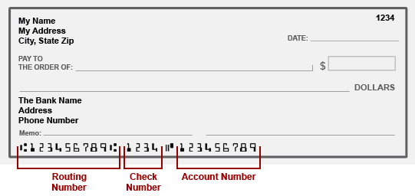

Automatic Charge to Credit Card
Authorization for Tri-Town YMCA to Charge Visa, Mastercard or Discover Card
I, [printed full name] authorize
Tri-Town YMCA to charge my

Type of Card: Visa ________ Mastercard _______ _ Discover ________
Frequency (circle one): Weekly Monthly One time only To begin ___/___/___
In the amount of $__________________ To end _________or at program
withdrawal which requires written confirmation sent to the Tri-Town YMCA office.
Please print:
Name on credit card:
Credit card number:
Expiration date: / / Security # [3 digits on back]
Signature: Today’s Date:

Address:
City: Zip:
Your daytime phone:

Child(ren)’s name(s):

Child(ren)’s School:
Return to: Tri-Town YMCA
1464 S. Main St. • Entrance #7 • Lombard, IL 60148
P 630-629-9622 • F 630-629-4636
info@tritownymca.org

