OUR PHILOSOPHY
The Tri-Town YMCA offers before and after school care to students in Lombard School District 44 and Villa Park School District 45. Our program is available to children from Kindergarten through 5th grade.
- Children are encouraged to be creative, and to develop new skills, interests and friendships.
- Daily activities may include group sports, homework assistance, arts and crafts, outside playtime and free time for games and other activities. A nutritious snack is also provided.
ABOUT OUR PROGRAM
Before-school care (7 a.m. to start of school) - at Manor Hill children are bussed to their schools in time for the start of school day.
Child’s School | Before-School Care
44/Hammerschmidt | At Manor Hill
44/Madison | At Manor Hill
44/Manor Hill | On-site
44/Pleasant Lane | On-site
45/Westmore | On-site
After-school care (end of school to 6 p.m.*) – at many locations with busing by the Tri-Town YMCA bus as needed. *late charge after 6 p.m.
Child’s School | After-School Care
44/Hammerschmidt | Bussed to Manor Hill
44/Madison | Bussed to Manor Hill
44/Manor Hill | On-site
44/Park View | Bussed to Pleasant Lane
44/Pleasant Lane | On-site
45/Ardmore | On-site
45/North | Bussed to Schafer
45/Schafer | On-site
45/Westmore | On-site
PROGRAM PRICING
Note: Deductions for school holidays and half days have been built into the pricing. Therefore, the payment amount is always the same.
Option 1: Monthly Installment fees have been determined by spreading the total cost of the program into 9 equal installments that are due by the 1st of each month beginning in September and ending in May.
Option 2: Weekly This 41-installment plan is available on an autopay basis (via credit card or deduction from your bank account). First payment is due August 15, 2012; last payment is due by May 22, 2013.

 | Monthly installment | Weekly installment
4-5 days/wk | $327.77 | $72
1-3 days/wk | $294.44 | $65
AM Only | $202.22 | $45
EARLY DISMISSAL
At Dist. 45 locations (where “early dismissal” is generally just an hour early), the afterschool program runs as usual beginning at the close of school. At Dist. 44 locations (where “half day” generally ends at 11:40 a.m.), afterschool care is made available as a separate program for an additional fee to those families who desire it.
Half-Day Program (Dist. 44 only) $28/day
REGISTRATION
To secure your child’s spot in our before/after school program, a $25 registration fee is required. Registration fees are non-refundable if you cancel from the program. If you drop from the program and decide to rejoin, you will pay an additional registration fee.
Payments can be made by mail, telephone, or in person at the Tri-Town YMCA office. Payments cannot be made at the school sites. Fees are prorated for those starting after the school year begins. Fee adjustments cannot be made for absences, personal vacations, or school closings.

Fee assistance is available through our Strong Kids Scholarship Program for qualifying families with demonstrated financial need. need.

Revised 4-2-2012
OUR QUALITY INDICATORS
- All programs are held in a safe environment. All programs offer an age-appropriate, balanced selection of activities.
- All children are responsibly supervised.
- All children are encouraged to participate in group activities as well as engage in self-guided pursuits.
- All staff under go a formal background check.
- All staff are trained to work with children and to deliver the program curriculum in a fun, caring atmosphere.
- All staff are trained in CPR and First Aid.
- A healthy snack is provided each day.

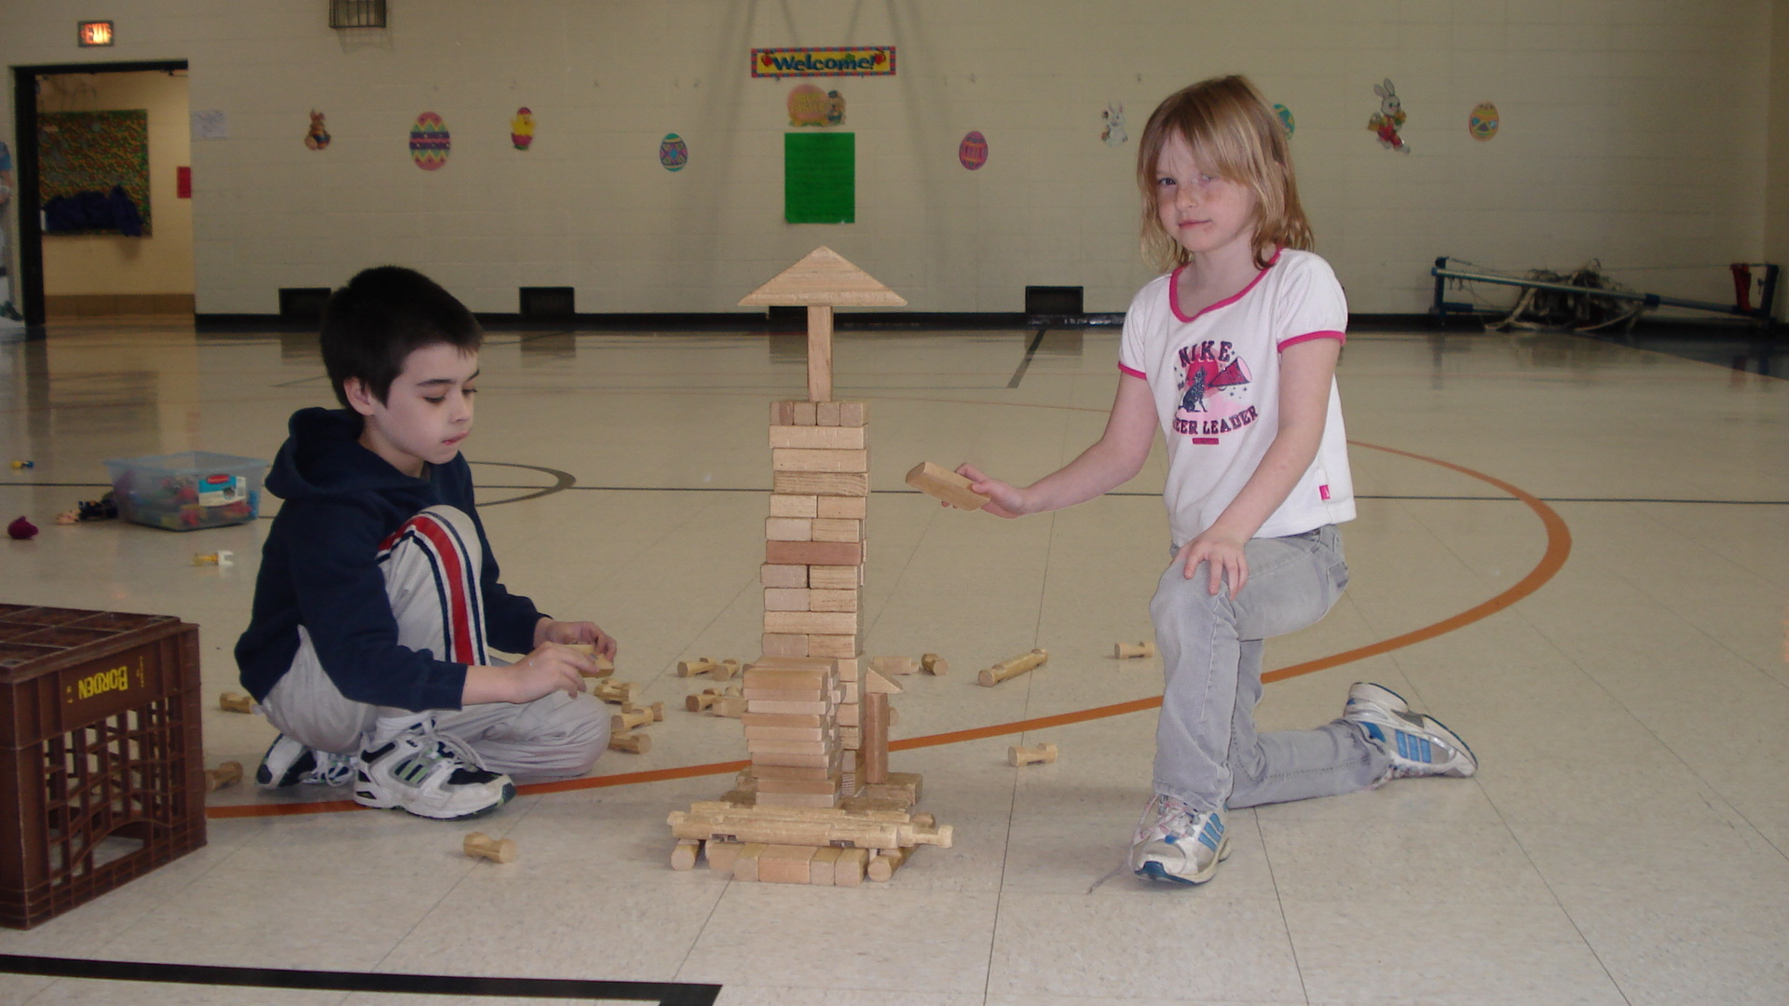
Questions?
Call Program Director
Chuck Pickerill, Tri-Town YMCA
630-629-9622.
Revised 4-2-2012
Y’S KIDS
2012-2013
Before & After School
Care



TRI-TOWN YMCA
1464 S. MAIN ST
LOMBARD, IL 60148
Phone (630) 629-9622
Fax (630) 629-4636
Email: info@tritownymca.org
Revised 4-2-2012

